Lab 2

**Lab Task**

1. Write a program for ohm’s law
   1. Define appropriate variable resistance, current and voltage
   2. Initialize all variables.
   3. Prompt the user to enter value for current and voltage measured
   4. Calculate resistance of unknown resistance
   5. Display all parameters appropriately
2. Write a program for first equation of motion
   1. Define appropriate variable initial velocity, final velocity, acceleration and time
   2. Initialize all variables.
   3. Prompt the user to enter value for initial velocity, acceleration and time
   4. Calculate final velocity
   5. Display all parameters appropriately

**Lab Drill Task**

1. Write program for average calculation
   1. Prompt user to enter marks for five subjects of second semester
      1. Appropriate variable names
      2. Initialize them
   2. Calculate the average
   3. Display the average marks obtained
2. Write a program for circumference calculation
   1. Define appropriate variable for radius and circumference of circle
   2. Initialize radius to “0” and circumference to 1.
   3. Prompt the user to enter radius
   4. Calculate the circumference
   5. Display radius and the circumference appropriately
3. Write a program for area and perimeter of rectangle
   1. Define appropriate variable for length, width, area and perimeter of rectangle
   2. Initialize length and width to “0” and area and perimeter to 1.
   3. Prompt the user to enter width and length
   4. Calculate area and perimeter of rectangle
   5. Display area and perimeter appropriately
4. Write a program for parallel resistance calculation
   1. Consider two resisters
   2. Define appropriate variable resister and net resistance
   3. Initialize all variables.
   4. Prompt the user to enter value for both resisters
   5. Calculate net resistance
   6. Display all parameters appropriately
5. Modify the above program for opposite branch current in parallel resistance
   1. Consider two resisters
   2. Define appropriate variable resister, total current and branch currents
   3. Initialize all variables.
   4. Prompt the user to enter value for both resisters and net current flowing
   5. Calculate both branch current
   6. Display all parameters appropriately
   7. Source (<https://www.electrical4u.com/current-divider/> )

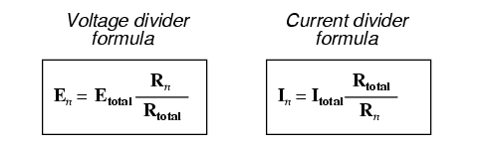

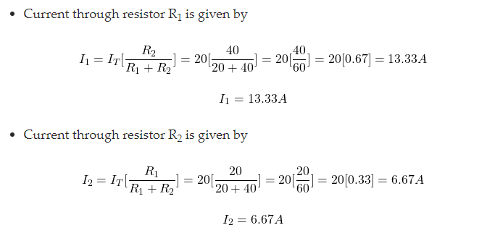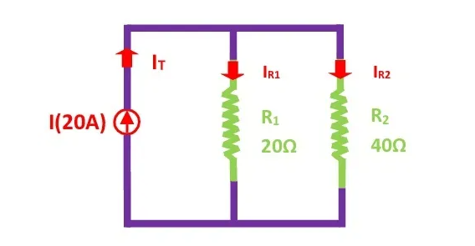

1. Write a program for star to delta conversion
   1. Consider two resisters
   2. Define appropriate variable for star and delta resistances
   3. Initialize all variables.
   4. Prompt the user to enter value for star resisters
   5. Calculate corresponding delta resistance
   6. Display all parameters appropriately

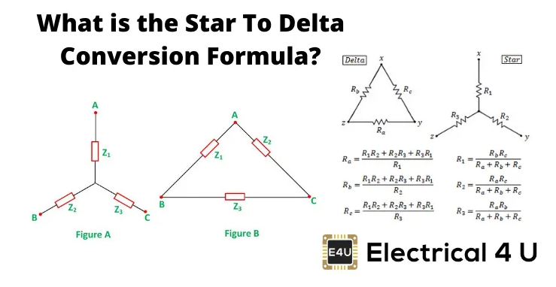

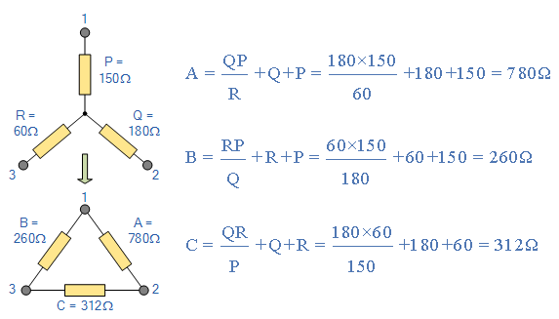

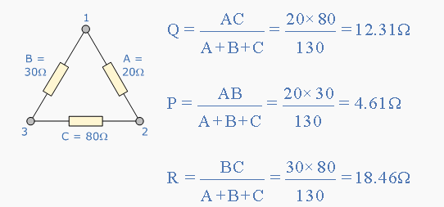

1. Equation: Consider the linear equation $y=2x+4$
   1. Declare two variable x and y
   2. Prompt the user to enter the value for x
   3. Calculate y
   4. Display
2. Calculation: Pythagoras theorem
   1. Define appropriate variable for base, perpendicular and hypotenuse
   2. Prompt the user to enter the values for base and perpendicular
   3. Calculate hypotenuse
   4. Display the result
3. Calculation: Roots of Quadratic Equation
   1. Define appropriate variable
   2. Prompt the user to enter the values for coefficients
   3. Calculate roots
   4. Display the result

